|  |
| --- |
| Experiment No. 9 |
| Implement Non-Restoring algorithm using c-programming |
| Name: Saloni Sutar |
| Roll Number: 58 |
| Date of Performance: |
| Date of Submission: |

**Aim -** To implement Non-Restoring division algorithm using c-programming.

**Objective -**

1. To understand the working of Non-Restoring division algorithm.
2. To understand how to implement Non-Restoring division algorithm using c-programming.

**Theory:**

In each cycle content of the register, A is first shifted and then the divisor is added or subtracted with the content of register A depending upon the sign of A. In this, there is no need of restoring, but if the remainder is negative then there is a need of restoring the remainder. This is the faster algorithm of division.

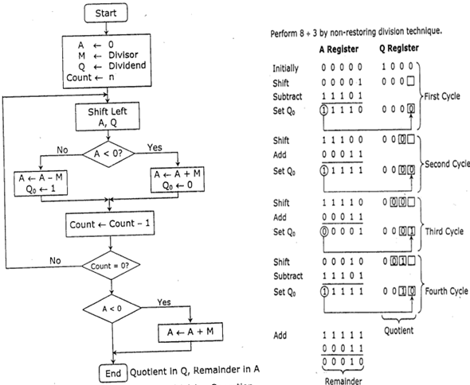

**Program -**

**#include <stdio.h>**

**#include <stdlib.h>**

**int dec_bin(int, int []);**

**int twos(int [], int []);**

**int left(int [], int []);**

**int add(int [], int []);**

**int main()**

**{**

**int a, b, m[4]={0,0,0,0}, q[4]={0,0,0,0}, acc[4]={0,0,0,0}, m2[4], i, n=4;**

**printf("Enter the Dividend: ");**

**scanf("%d", &a);**

**printf("Enter the Divisor: ");**

**scanf("%d", &b);**

**dec_bin(a, q);**

**dec_bin(b, m);**

**twos(m, m2);**

**printf("\nA\tQ\tComments\n");**

**for(i=3; i>=0; i--)**

**{**

**printf("%d", acc[i]);**

**}**

**printf("\t");**

**for(i=3; i>=0; i--)**

**{**

**printf("%d", q[i]);**

**}**

**printf("\tStart\n");**

**while(n>0)**

**{**

**left(acc, q);**

**for(i=3; i>=0; i--)**

**{**

**printf("%d", acc[i]);**

**}**

**printf("\t");**

**for(i=3; i>=1; i--)**

**{**

**printf("%d", q[i]);**

**}**

**printf("_\tLeft Shift A,Q\n");**

**add(acc, m2);**

**for(i=3; i>=0; i--)**

**{**

**printf("%d", acc[i]);**

**}**

**printf("\t");**

**for(i=3; i>=1; i--)**

**{**

**printf("%d", q[i]);**

**}**

**printf("_\tA=A-M\n");**

**if(acc[3]==0)**

**{**

**q[0]=1;**

**for(i=3; i>=0; i--)**

**{**

**printf("%d", acc[i]);**

**}**

**printf("\t");**

**for(i=3; i>=0; i--)**

**{**

**printf("%d", q[i]);**

**}**

**printf("\tQo=1\n");**

**}**

**else**

**{**

**q[0]=0;**

**add(acc, m);**

**for(i=3; i>=0; i--)**

**{**

**printf("%d", acc[i]);**

**}**

**printf("\t");**

**for(i=3; i>=0; i--)**

**{**

**printf("%d", q[i]);**

**}**

**printf("\tQo=0; A=A+M\n");**

**}**

**n--;**

**}**

**printf("\nQuotient = ");**

**for(i=3; i>=0; i--)**

**{**

**printf("%d", q[i]);**

**}**

**printf("\tRemainder = ");**

**for(i=3; i>=0; i--)**

**{**

**printf("%d", acc[i]);**

**}**

**printf("\n");**

**return 0;**

**}**

**int dec_bin(int d, int m[])**

**{**

**int b=0, i=0;**

**for(i=0; i<4; i++)**

**{**

**m[i]=d%2;**

**d=d/2;**

**}**

**return 0;**

**}**

**int twos(int m[], int m2[])**

**{**

**int i, m1[4];**

**for(i=0; i<4; i++)**

**{**

**if(m[i]==0)**

**{**

**m1[i]=1;**

**}**

**else**

**{**

**m1[i]=0;**

**}**

**}**

**for(i=0; i<4; i++)**

**{**

**m2[i]=m1[i];**

**}**

**if(m2[0]==0)**

**{**

**m2[0]=1;**

**}**

**else**

**{**

**m2[0]=0;**

**if(m2[1]==0)**

**{**

**m2[1]=1;**

**}**

**else**

**{**

**m2[1]=0;**

**if(m2[2]==0)**

**{**

**m2[2]=1;**

**}**

**else**

**{**

**m2[2]=0;**

**if(m2[3]==0)**

**{**

**m2[3]=1;**

**}**

**else**

**{**

**m2[3]=0;**

**}**

**}**

**}**

**}**

**return 0;**

**}**

**int left(int acc[], int q[])**

**{**

**int i;**

**for(i=3; i>0; i--)**

**{**

**acc[i]=acc[i-1];**

**}**

**acc[0]=q[3];**

**for(i=3; i>0; i--)**

**{**

**q[i]=q[i-1];**

**}**

**}**

**int add(int acc[], int m[])**

**{**

**int i, carry=0;**

**for(i=0; i<4; i++)**

**{**

**if(acc[i]+m[i]+carry==0)**

**{**

**acc[i]=0;**

**carry=0;**

**}**

**else if(acc[i]+m[i]+carry==1)**

**{**

**acc[i]=1;**

**carry=0;**

**}**

**else if(acc[i]+m[i]+carry==2)**

**{**

**acc[i]=0;**

**carry=1;**

**}**

**else if(acc[i]+m[i]+carry==3)**

**{**

**acc[i]=1;**

**carry=1;**

**}**

**}**

**return 0;**

**}**

**Output:**

**Enter the Dividend: 10**

**Enter the Divisor: 2**

**A Q Comments**

**0000 1010 Start**

**0001 010_ Left Shift A,Q**

**1111 010_ A=A-M**

**0001 0100 Qo=0; A=A+M**

**0010 100_ Left Shift A,Q**

**0000 100_ A=A-M**

**0000 1001 Qo=1**

**0001 001_ Left Shift A,Q**

**1111 001_ A=A-M**

**0001 0010 Qo=0; A=A+M**

**0010 010_ Left Shift A,Q**

**0000 010_ A=A-M**

**0000 0101 Qo=1**

**Quotient = 0101 Remainder = 0000**

**Conclusion -**

This experiment and code implementation of the Non-Restoring Division Algorithm have provided valuable insights into the world of binary division.We have demonstrated the algorithm's effectiveness in dividing binary numbers without the need for restoring operations, making it suitable for hardware implementations where efficiency is critical. This experiment has not only showcased the power of algorithmic optimization in digital computation but has also illustrated the practical application of non-restoring division as a reliable method for achieving precise binary division in a hardware context.